Here Goes the Title for your Abstract to RCEM 2023 - Symposium on River,
Coastal, and Estuarine Morphodynamics (Times 14, Bold)
A. Lastname¹, B.C. Lastname² and D. Lastname^{1,3}
¹ Department of Civil and Environmental Engineering, University of Illinois at Urbana-Champaign, Urbana, USA. author1@email.edu
² Department of Geosciences, University of Gotham, Gotham, USA, author2@email.edu
³ Now at Department of Aerodynamics, University of Metropolis, Metropolis, USA, author3@email.edu

1. Introduction
Please follow this format for your abstract. Your abstract should be no more than 1-page. The template is used to format the page and the style of the text. All margins (1 in), column widths, line spaces, and text fonts are provided in this document; please do not alter them.
Abstracts should be one page long, in US-letter size and two-column format. Section titles should be in “bold” and in “Times new Roman”, size 11. Text in the paragraph should be “Times new Roman”, size 10.

2. Formatting: figures, tables, equations, items, references
Please follow guidelines below for figures, tables, equations, and citations.

2.1 Figures
Figures in color or black and white (e.g. Figure 1) can be included in the abstract.

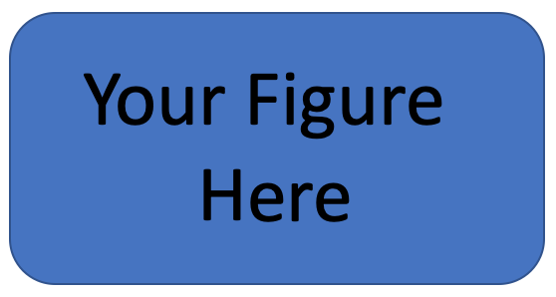
Figure 1. Figure captions should be centered and in “Times new Roman”, size 10.

2.2 Tables
Tables (e.g. Table 1) can be included.

Table 1. Table caption on top of table.
R | C | E | M
2 | 0 | 2 | 3
U | I | U | C

2.3 Equations
If required, equations (e.g. Equation 1) can be included. Please use the following format (“equation editor” for word users):

$RCEM=UI+UC^{2023}$ (1)

where R is Rivers, C is Coastal, and you know the rest. Simple equations can also be inserted in the text using, for instance: $α=β+γ$.

2.4 Itemized lists
Itemized lists should appear according to the following format:
- First line
- Second line
- Third line

2.5 References
References will appear at the end of the abstract. List citations alphabetically in the reference section. Three examples of citations are given in this document (Jones et al., 2020; Smith and Jones, 2021; Smith 2022). They could be cited as Jones et al. (2020), Smith and Jones (2021) and Smith (2022).

3. Conclusions
The conclusions should be clear and to the point.

Acknowledgments
We thank our Collaborators, Sponsors, Funding agencies, and everyone else involved in this project.

References
Jones, J. Smith, S., & Johnson, J.J. (2020). On the art of writing abstracts. J. Asbtract Res. 1-109, pp 101-102, doi:12.3456/2020JARF0001.
Smith, S. (2022). How to create a template. J. Template Sci. 2-10, pp 119-139. doi: 10.9876/543-21-001.
Smith, S. & Jones, J. (2021). Writing references: Are DOI useful?. J. Paper Citing, pp 10-20. doi: 00.000/2021JPC-123-456.

